Port Underwood Association

PO Box 59

Blenheim 7240

30 September 2016

Marlborough District Council

15 Seymour Street

Blenheim 7201

Dear Sir,

**Request for information**

This is a request for information held by the Marlborough District Council under the provisions of the *Local Government Official Information And Meetings Act 1987*. This concerns the Port Underwood Road (from Whatamango Bay to Whites Bay) and Tumbledown Bay Road. The information requested is in three sections:

* Amounts received as contributions for development consents;
* Amounts paid by rate payers for road maintenance and improvement; and
* The amounts spent on maintenance and improvement of roads.

1. Contributions
   1. What is the amount paid by developers for residential properties per year for the past five years as contributions when applying for or receiving resource consents?
   2. What is the amount paid by developers of marine farms per year for the past five years as contributions when applying for or receiving resource consents?
   3. What is the amount paid by developers of forestry lots per year for the past five years as contributions when applying for or receiving resource consents?
   4. What is the amount paid by any other developers per year for the past five years as contributions when applying for or receiving resource consents?
2. Rates payments
   1. How much of the rates collected from residential property owners in Port Underwood (properties from Whatamango Bay to Whites Bay) is allocated to or is a charge for roading per year for the past five years?
   2. How much of the rates collected from marine farms in Port Underwood is allocated to or is a charge for roading per year for the past five years?
   3. How much of the rates collected from forestry owners in Port Underwood is allocated to or is a charge for roading per year for the past five years?
   4. How much of the rates collected from any other user or occupier in Port Underwood is allocated to or is a charge for roading per year for the past five years?
3. Expenditure
   1. How much has been spent on road improvements per year for the past five years on the Port Underwood Road (from Whatamango Bay to Whites Bay) and Tumbledown Bay Road?
   2. How has been spent on road maintenance per year for the past five years on the Port Underwood Road (from Whatamango Bay to Whites Bay) and Tumbledown Bay Road?
   3. What road improvements have actually been undertaken in the areas mentioned above?

Yours sincerely

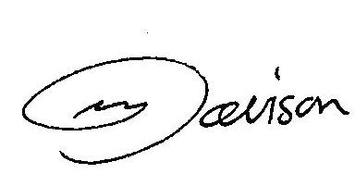

John Davison

Chairman

Port Underwood Association